**TEAM ID:PMT2022TMIT50401**

['id', 'week', 'checkout_price', 'base_price', 'emailer_for_promotion', 'ho mepage_featured', 'num_orders', 'category', 'cuisine', 'city_code', 'region

_code', 'center_type', 'op_area']

# In [27]:

cols **=** cols[:2] **+** cols[9:] **+** cols[7:9] **+** cols[2:7] print(cols)

['id', 'week', 'city_code', 'region_code', 'center_type', 'op_area', 'categ ory', 'cuisine', 'checkout_price', 'base_price', 'emailer_for_promotion', ' homepage_featured', 'num_orders']

In[28]

trainfinal **=** trainfinal[cols] trainfinal**.**dtypes

Out[28]

id int64

week int64

city_code int64

region_code int64

center_type object

op_area float64

category object

cuisine object

checkout_price float64

base_price float64 emailer_for_promotion int64 homepage_featured int64

num_orders int64

dtype: object

In[30]

**from** sklearn.preprocessing **import** LabelEncoder

In[32]

lb1 **=** LabelEncoder()

trainfinal['center_type'] **=** lb1**.**fit_transform(trainfinal['center_type']) lb2 **=** LabelEncoder()

trainfinal['category'] **=** lb1**.**fit_transform(trainfinal['category']) lb3 **=** LabelEncoder()

trainfinal['cuisine'] **=** lb1**.**fit_transform(trainfinal['cuisine'])

In[33]

trainfinal**.**head()

# I

**TEAM ID: PNT2022TMID50401**

|  |  |  |  |  |  |  |  |  |  |  |  |  |  |
| --- | --- | --- | --- | --- | --- | --- | --- | --- | --- | --- | --- | --- | --- |
|  | **id** | **w**  **ee k** | **city**  **_co de** | **regio**  **n_co de** | **cente**  **r_typ**  **e** | **op_**  **are a** | **cat**  **ego ry** | **cui**  **sin e** | **checko**  **ut_pric**  **e** | **base**  **_pric**  **e** | **emailer_fo**  **r_promotio**  **n** | **homepag**  **e_feature**  **d** | **num_**  **order**  **s** |
| **0** | 137  956  0 | 1 | 647 | 56 | 2 | 2.0 | 0 | 3 | 136.83 | 152.  29 | 0 | 0 | 177 |
| **1** | 101  870  4 | 2 | 647 | 56 | 2 | 2.0 | 0 | 3 | 135.83 | 152.  29 | 0 | 0 | 323 |
| **2** | 119  627  3 | 3 | 647 | 56 | 2 | 2.0 | 0 | 3 | 132.92 | 133.  92 | 0 | 0 | 96 |
| **3** | 111  652  7 | 4 | 647 | 56 | 2 | 2.0 | 0 | 3 | 135.86 | 134.  86 | 0 | 0 | 163 |
| **4** | 134  387  2 | 5 | 647 | 56 | 2 | 2.0 | 0 | 3 | 146.50 | 147.  50 | 0 | 0 | 215 |

trainfinal**.** shape

Out[34]

(456548, 13)

In[36]

plt**.**style**.**use('fivethirtyeight') plt**.**figure(figsize**=**(12,7)) sns**.**distplot(trainfinal**.**num_orders, bins **=** 25) plt**.**xlabel("num_orders")

plt**.**ylabel("Number of Buyers") plt**.**title("num_orders Distribution")

c:\Users\NANDHITHA\Anaconda3\lib\site-packages\seaborn\distributions.py:261 9: FutureWarning: `distplot` is a deprecated function and will be removed i n a future version. Please adapt your code to use either `displot` (a figur e-level function with similar flexibility) or `histplot` (an axes-level fun ction for histograms).

warnings.warn(msg, FutureWarning)

Out[36]

Text(0.5, 1.0, 'num_orders Distribution')

**TEAM ID: PNT2022TMID50401**

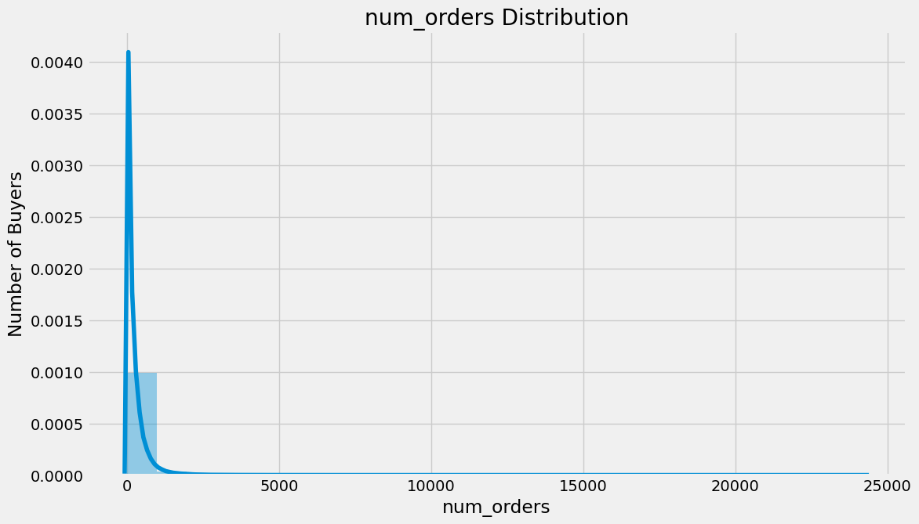

trainfinal2 **=** trainfinal**.**drop(['id'], axis**=**1) correlation **=** trainfinal2**.**corr(method**=**'pearson') columns **=** correlation**.**nlargest (8, 'num_orders')**.**index columns

# In [37]:

Out[37]:

Index(['num_orders', 'homepage_featured', 'emailer_for_promotion', 'op_area ',

'cuisine', 'city_code', 'region_code', 'category'], dtype='object')

correlation_map **=** np**.**corrcoef(trainfinal2[columns]**.**values**.**T) sns**.**set(font_scale**=**1.0)

heatmap **=** sns**.**heatmap(correlation_map, cbar**=True**, annot**=True**, square**=True**, fmt**=**'.2f',

yticklabels**=**columns**.**values, xticklabels**=**columns**.**values) plt**.**show()

# In [39]:

**TEAM ID: PNT2022TMID50401**

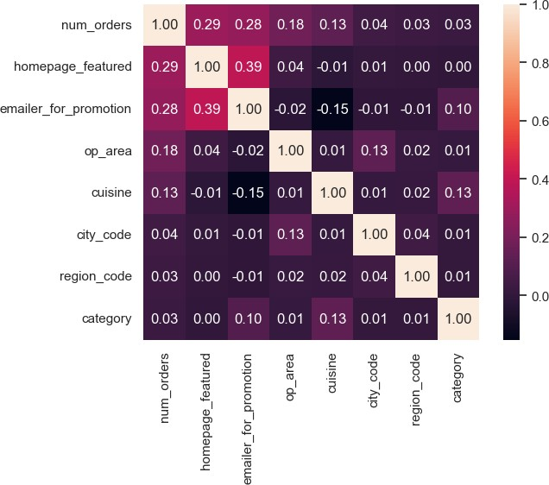

features **=** columns**.**drop(['num_orders']) trainfinal3 **=** trainfinal[features]

X **=** trainfinal3**.**values

y **=** trainfinal[ 'num_orders']**.**values

trainfinal3**.**head()

# In [41]:

In [42]:

# Out[42]:

|  |  |  |  |  |  |  |  |
| --- | --- | --- | --- | --- | --- | --- | --- |
| **homepage_featured** | | **emailer_for_promotion** | **op_area** | **cuisine** | **city_code** | **region_code** | **category** |
| **0** | 0 | 0 | 2.0 | 3 | 647 | 56 | 0 |
| **1** | 0 | 0 | 2.0 | 3 | 647 | 56 | 0 |
|  |  |  |  |  |  |  |  |
|  |  | **TEAMID:PNT2022TMID50401** |  |  |  |  |  |

|  |  |  |  |  |  |  |  |
| --- | --- | --- | --- | --- | --- | --- | --- |
| **homepage_featured** | | **emailer_for_promotion** | **op_area** | **cuisine** | **city_code** | **region_code** | **category** |
| **2** | 0 | 0 | 2.0 | 3 | 647 | 56 | 0 |
| **3** | 0 | 0 | 2.0 | 3 | 647 | 56 | 0 |
| **4** | 0 | 0 | 2.0 | 3 | 647 | 56 | 0 |

**from** sklearn.model_selection **import** train_test_split

# In [45]:

In [47]:

X_train, X_val, y_train, y_val **=** train_test_split(X, y, test_size**=**0.25)